Pratyusha Thundena

Homework 2

FA2017 CS 103L-F4 Introduction to Computation Lab

October 16, 2017

Source Code

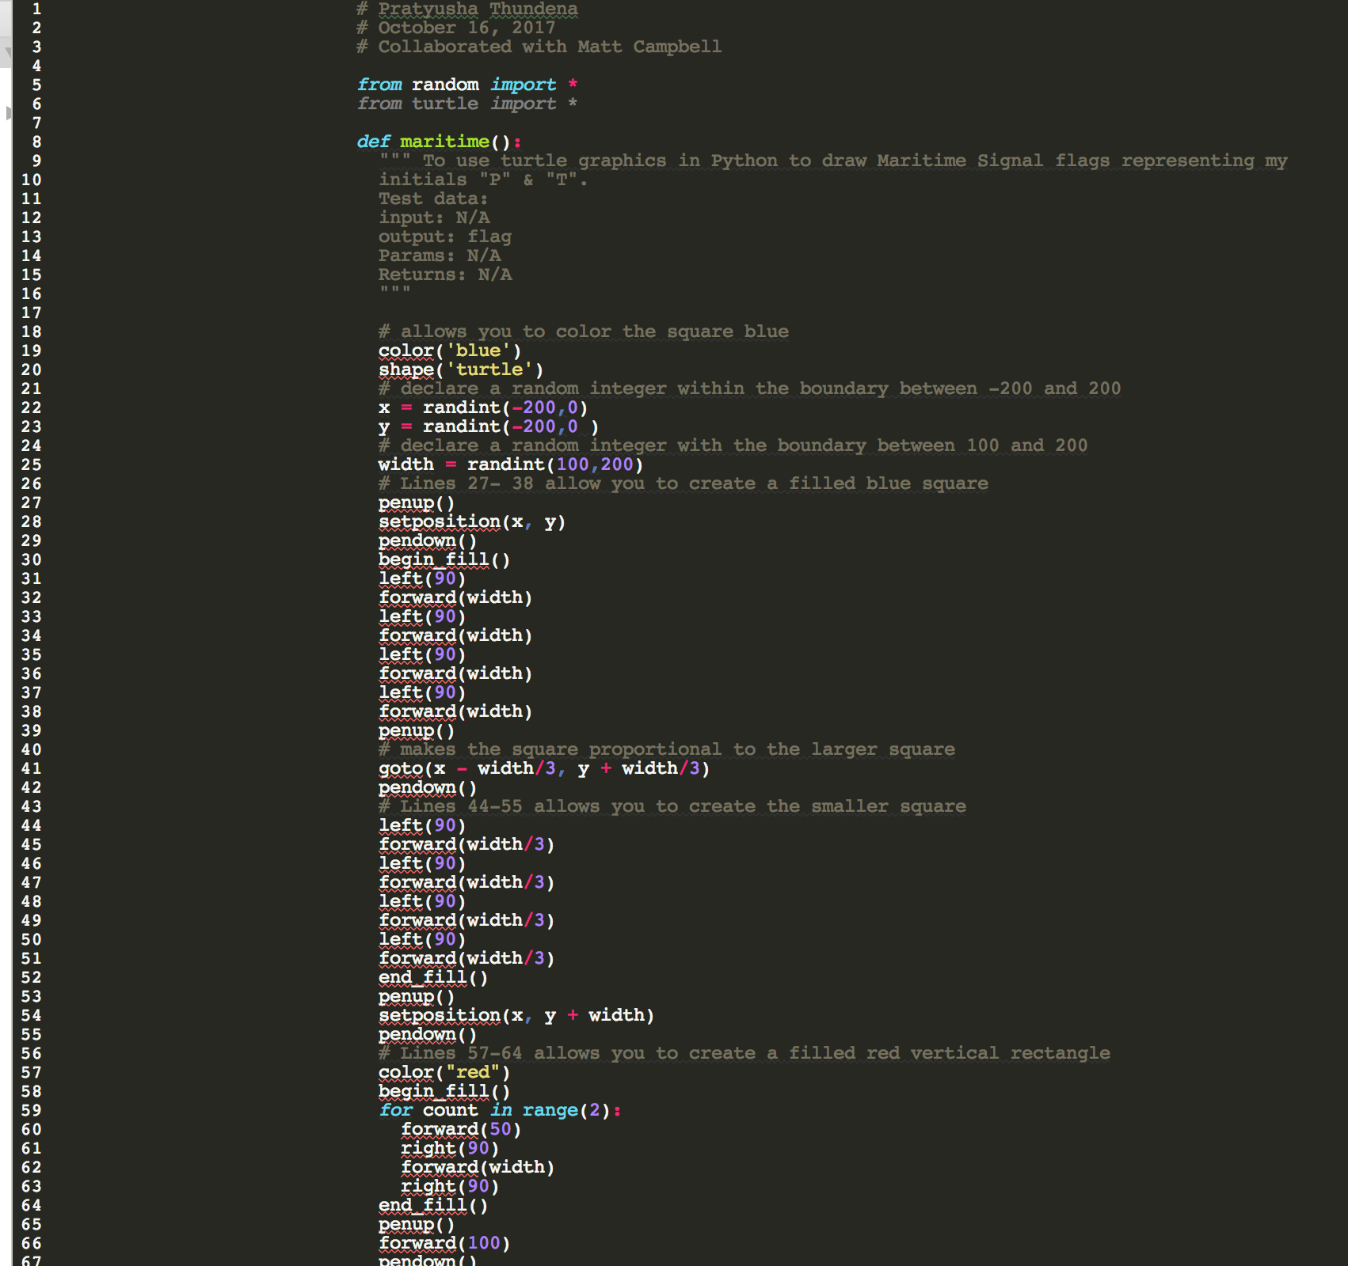

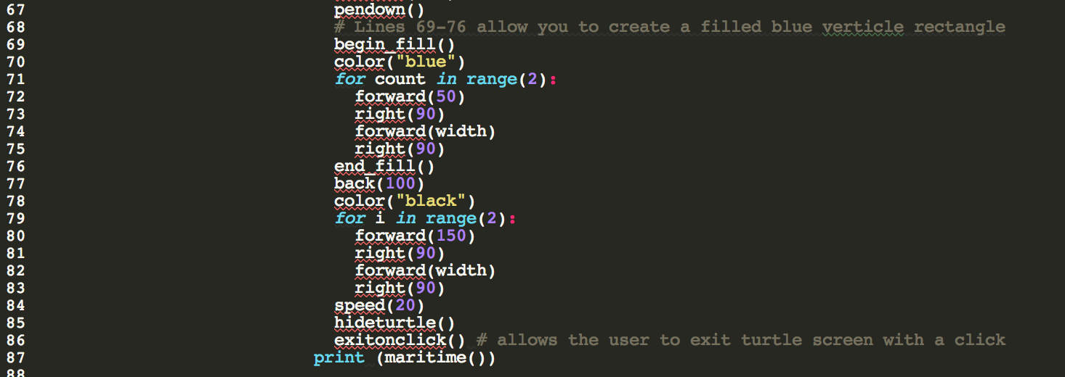

Demonstration to TA

Source codes demonstrated on 10/16/2017 at approximately 1:40 pm (CST) to BreAunna.

Program Results

Output 1:

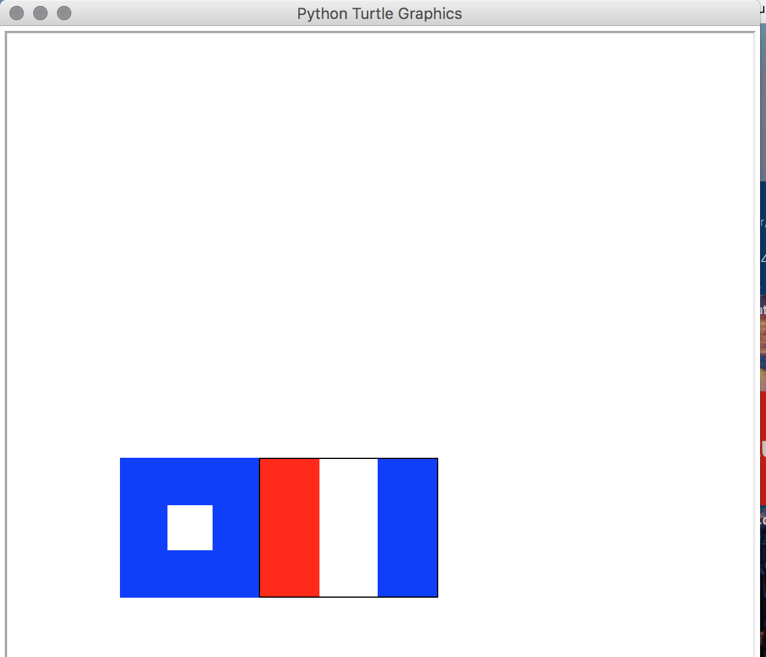

Output 2:

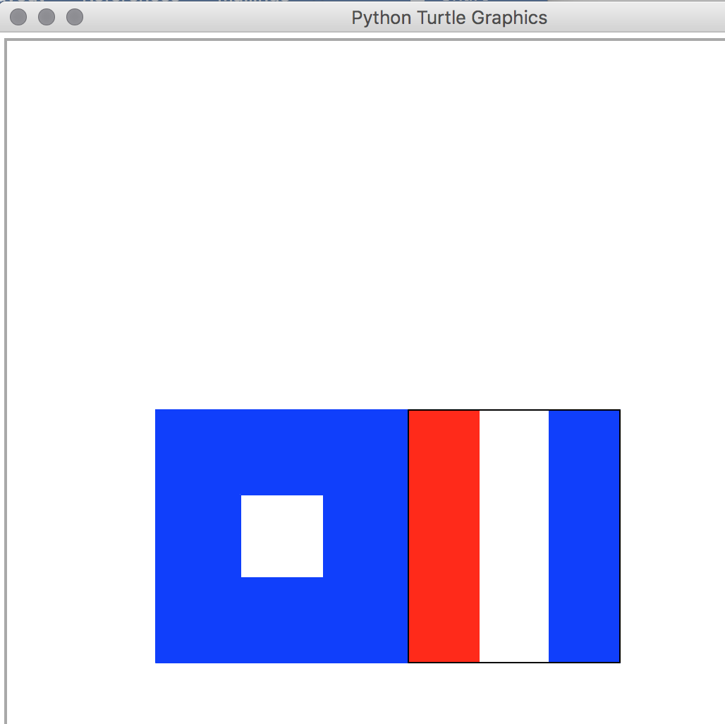

Output 3:

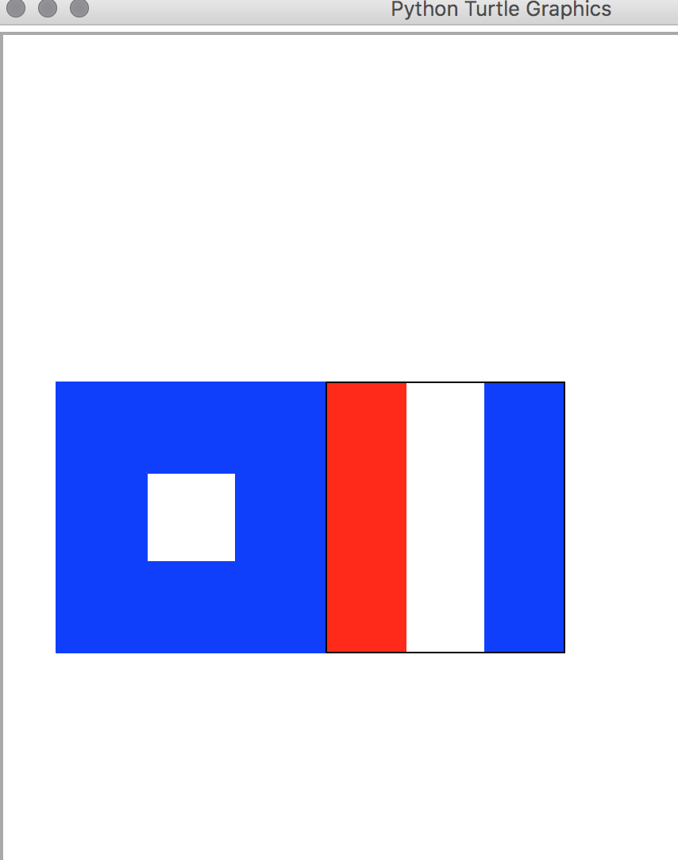

Conclusion and Results

The objective of this assignment was to use random numbers to create a flag combining

my initials “P” and “T” ( <https://en.wikipedia.org/wiki/International_maritime_signal_flags> ). I

had to choose a point at random in the square bounded by points (-200, -200), (0, -200), (0,0) and

(-200,0), which would ensure that the flag would be located somewhere within the third

quadrant. The width at random had to be in (100,200) and each letter flag had to be of that width.

These constraints were placed in order for each letter flag to properly fit in the square. The most

challenging part of this lab was figuring out the purpose of setting up the boundary (-200,0). I

used Stack Overflow to get help with boundary settings; however, it was not very useful

(<https://stackoverflow.com/questions/46751242/python-turtle-module-creating-a-flag)>. Then, I

used the Python reference library and I was able to solve the problem by playing around with

different functions (<https://docs.python.org/2/library/random.html)>. Afterwards, I just had to

create the two flags using the information from the other Python turtle labs. Then, I ran several

different test cases in order to ensure that the size and the position of the flag did change (Output

1, Output 2, Output 3).